 | 12.1.11 Editors - Geometry Nodes Editor - Header - Add Menu - Material
Table of content
Detailed table of content 1
Add menu - Mesh 1
Material Assign 2
Material Replace 2
Select by Material 3

Detailed table of content
Detailed table of content
Detailed table of content 1
Add menu - Mesh 1
Material Assign 2
Inputs 2
Geometry 2
Material 2
Selection 2
Output 2
Geometry 2
Material Replace 2
Inputs 2
Geometry 2
Old 2
New 2
Outputs 3
Geometry 3
Select by Material 3
Inputs 3
Geometry 3
Material 3
Selection 3
Outputs 3
Geometry 3

Add menu - Mesh
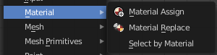
Nodes to modify the material.

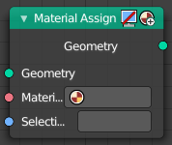
Material Assign
Assign a material to a mesh or a selection of a mesh.

Inputs

Geometry
The geometry that you want to assign the material to.

Material
The material that you want to assign.

Selection
The selection that you want to assign the material to.

Output

Geometry
Standard geometry output.

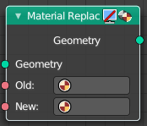
Material Replace
Replace an existing material by a new material.

Inputs

Geometry
The geometry that you want to assign the material to.

Old
The old material.

New
The new material.

Outputs

Geometry
Standard geometry output.

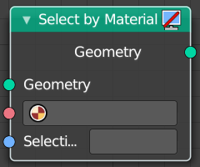
Select by Material
Select geometry by Material

Inputs

Geometry
The geometry where you want to select the geometry with the material.

Material
The material.

Selection
A selection of the mesh.

Outputs

Geometry
Standard geometry output.

